Spring’ 2026
Human Computer Interaction

StudyBuddy
“Find study partners - build study groups - track progress”

Wire-framing And Prototype Building

Low Fidelity Wire-frames:

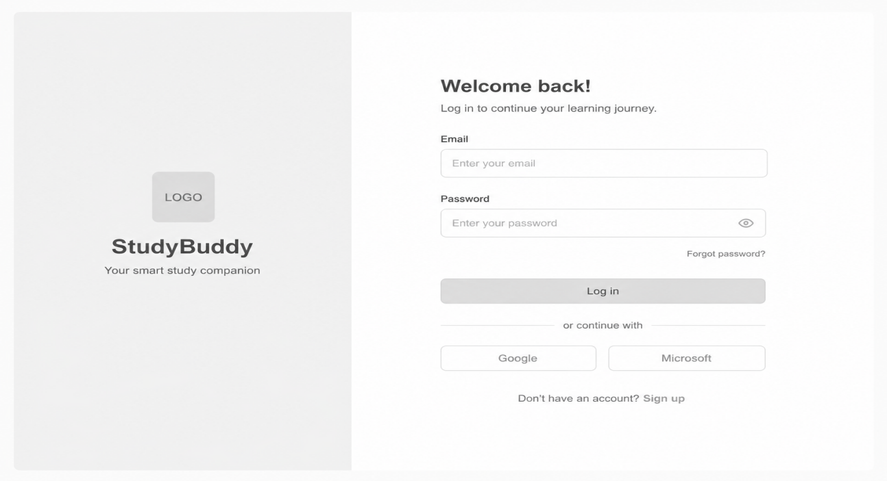
Login Page Low Fidelity Wireframe 1

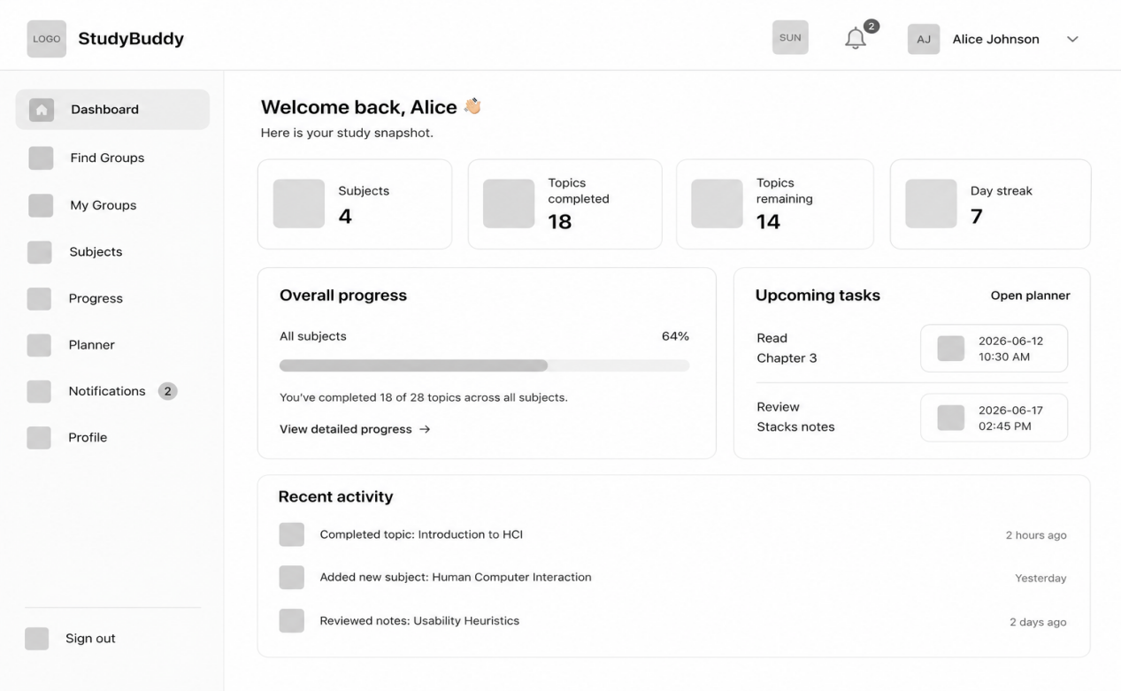
Dashboard Low Fidelity Wireframe 2

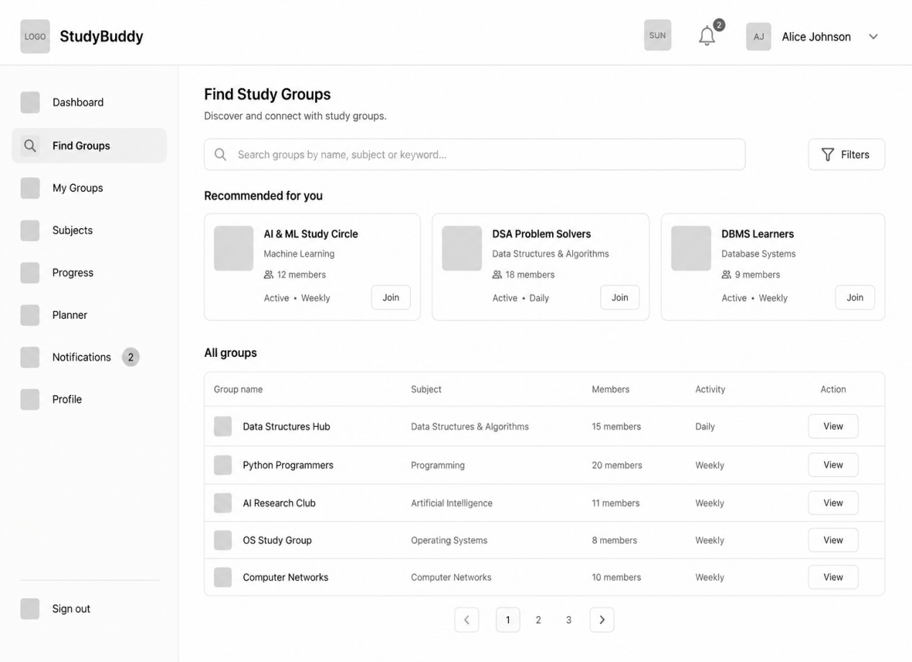
Study Groups Low Fidelity Wireframe 3

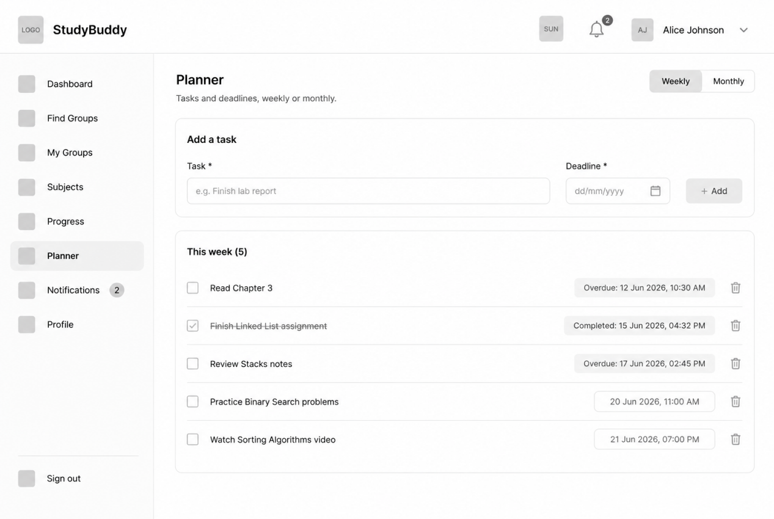
Planner Low Fidelity Wireframe 4

High Fidelity Prototype:

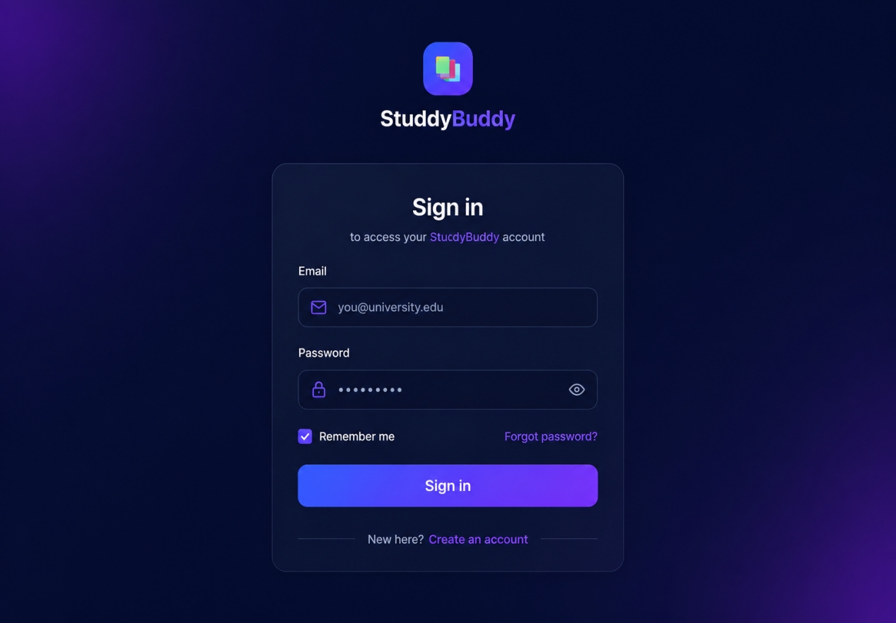
Login Page Prototype 1

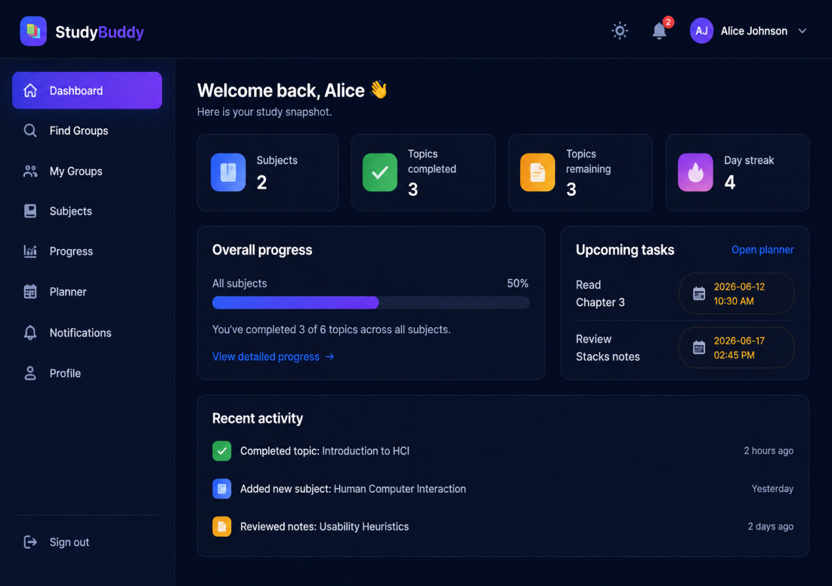
Dashboard Prototype 2

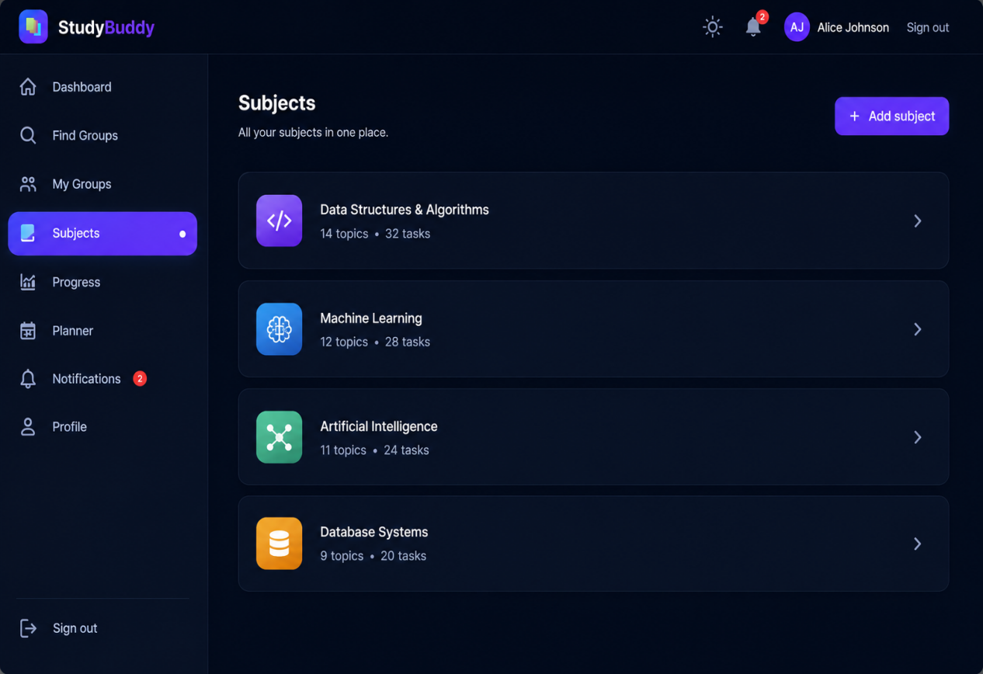
Subjects Page Prototype 3

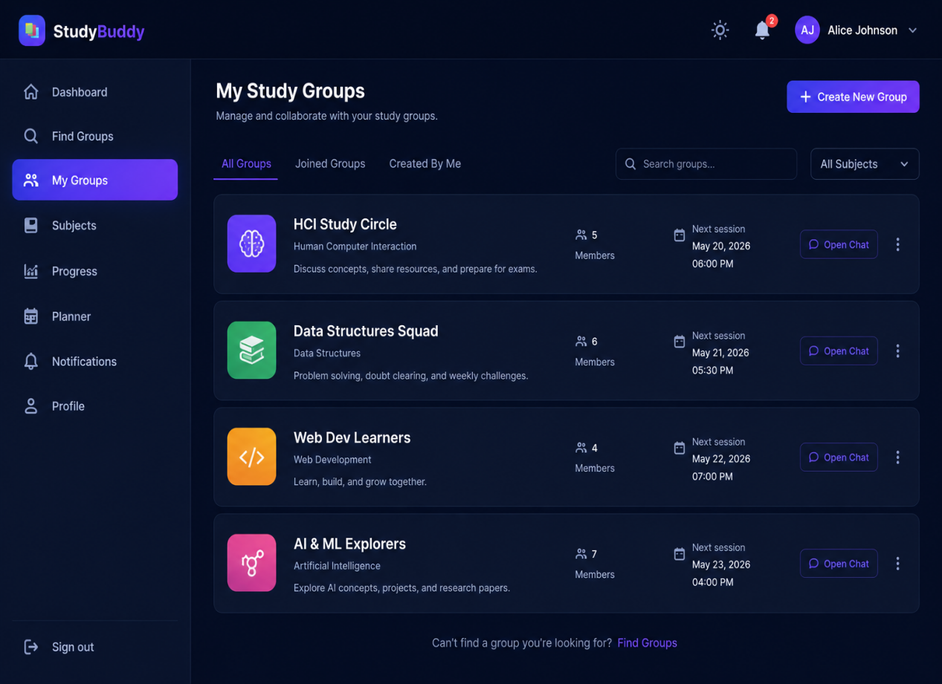
My Groups Page Prototype 4

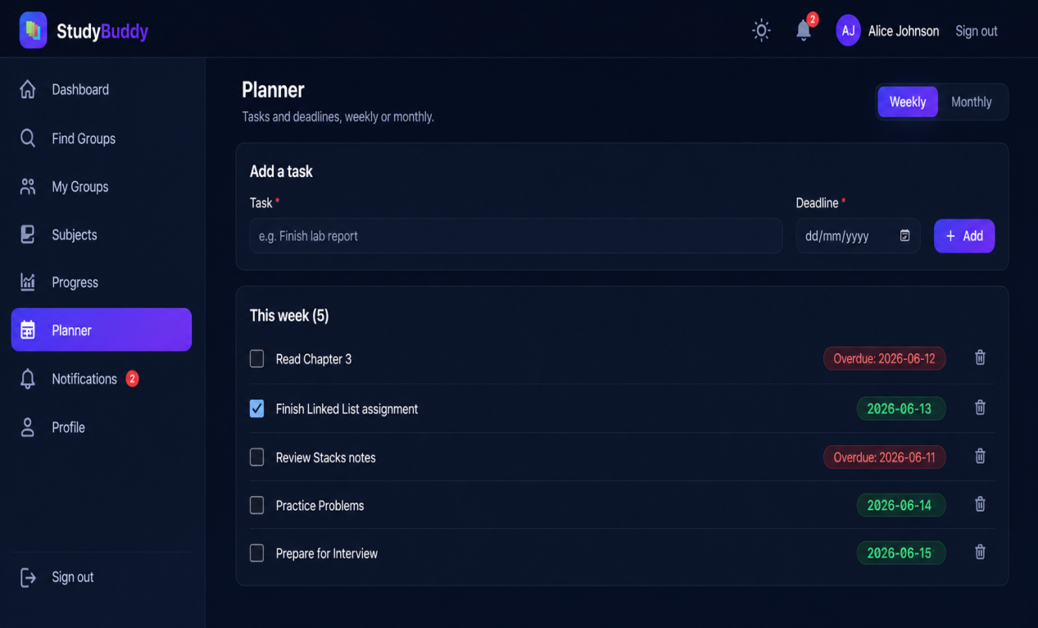
Planner Prototype 5

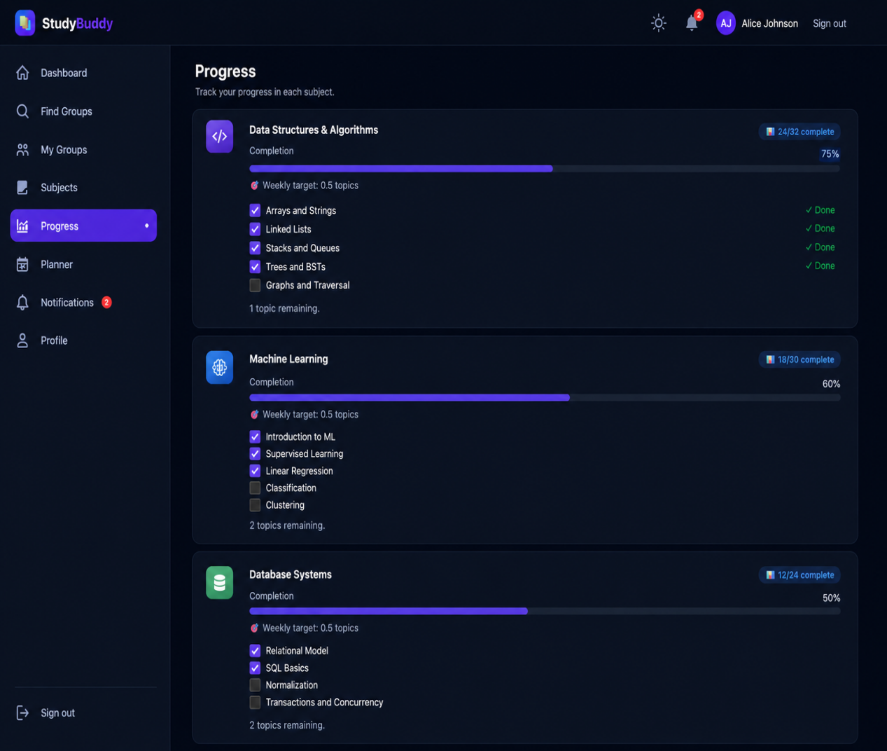
Progress Prototype 6

